ReffRebound Figures

Weihsueh Chiu

2020-09-17

## Load results

## Refft at min

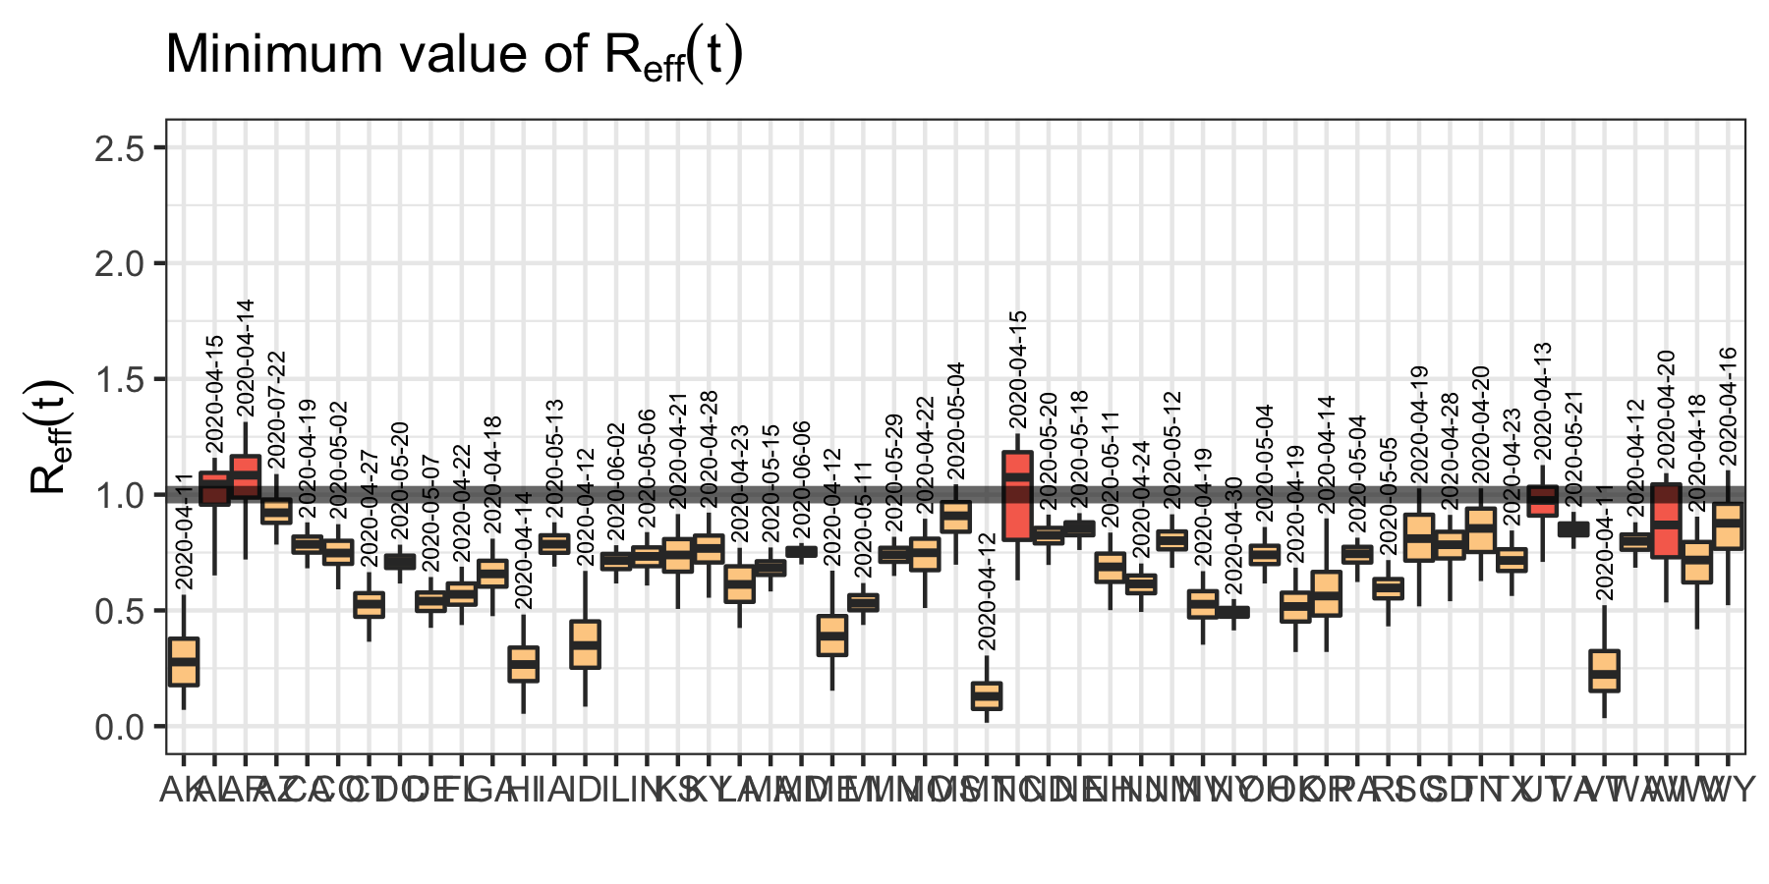

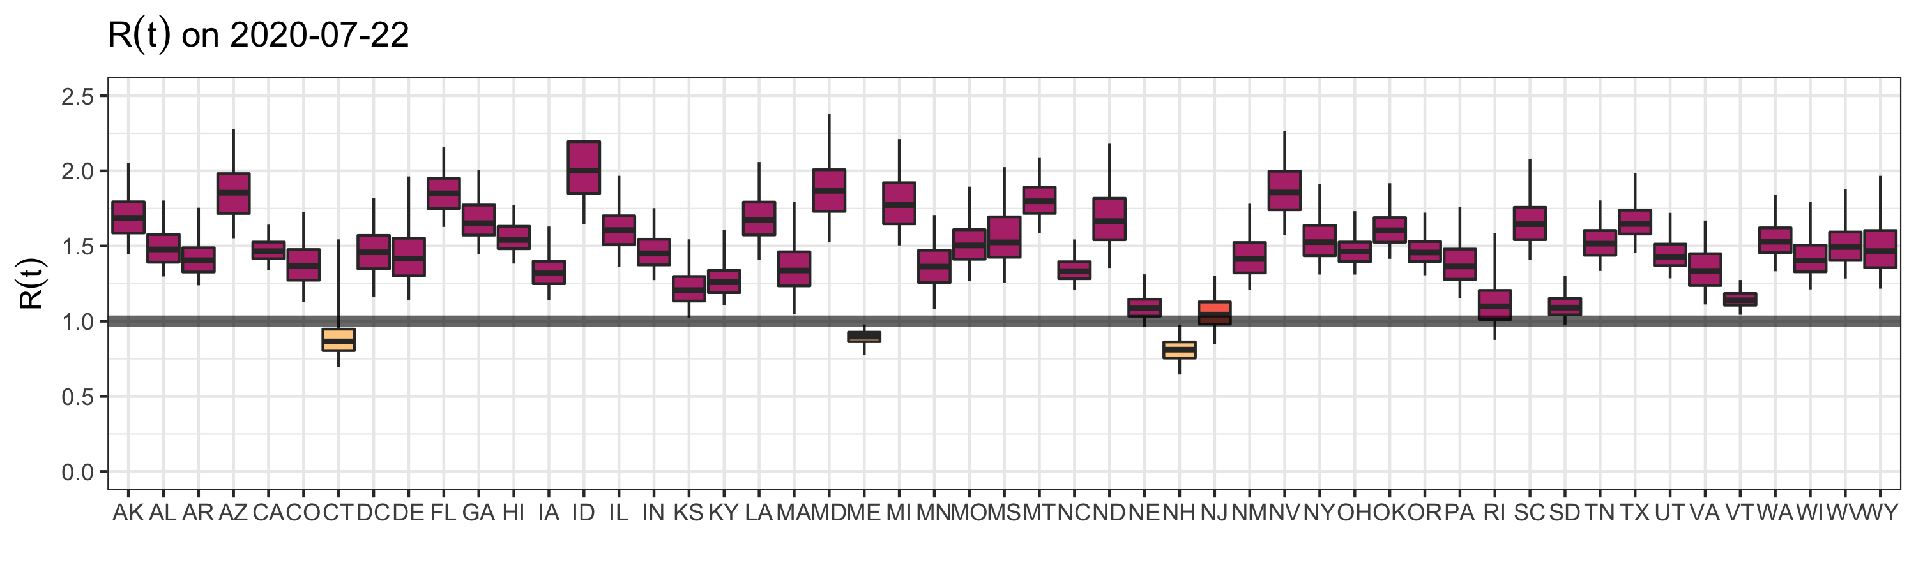

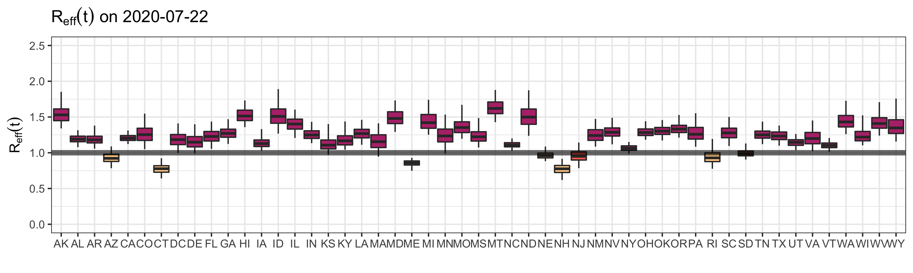

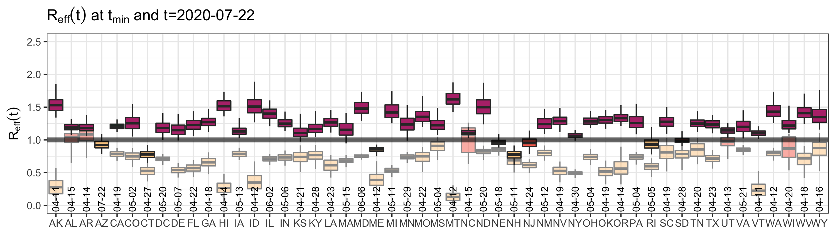

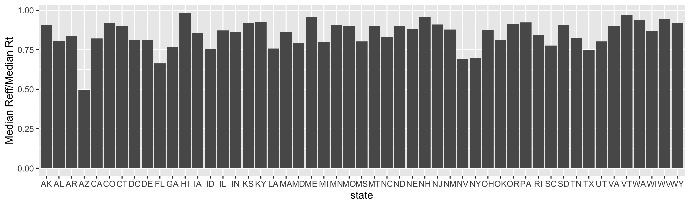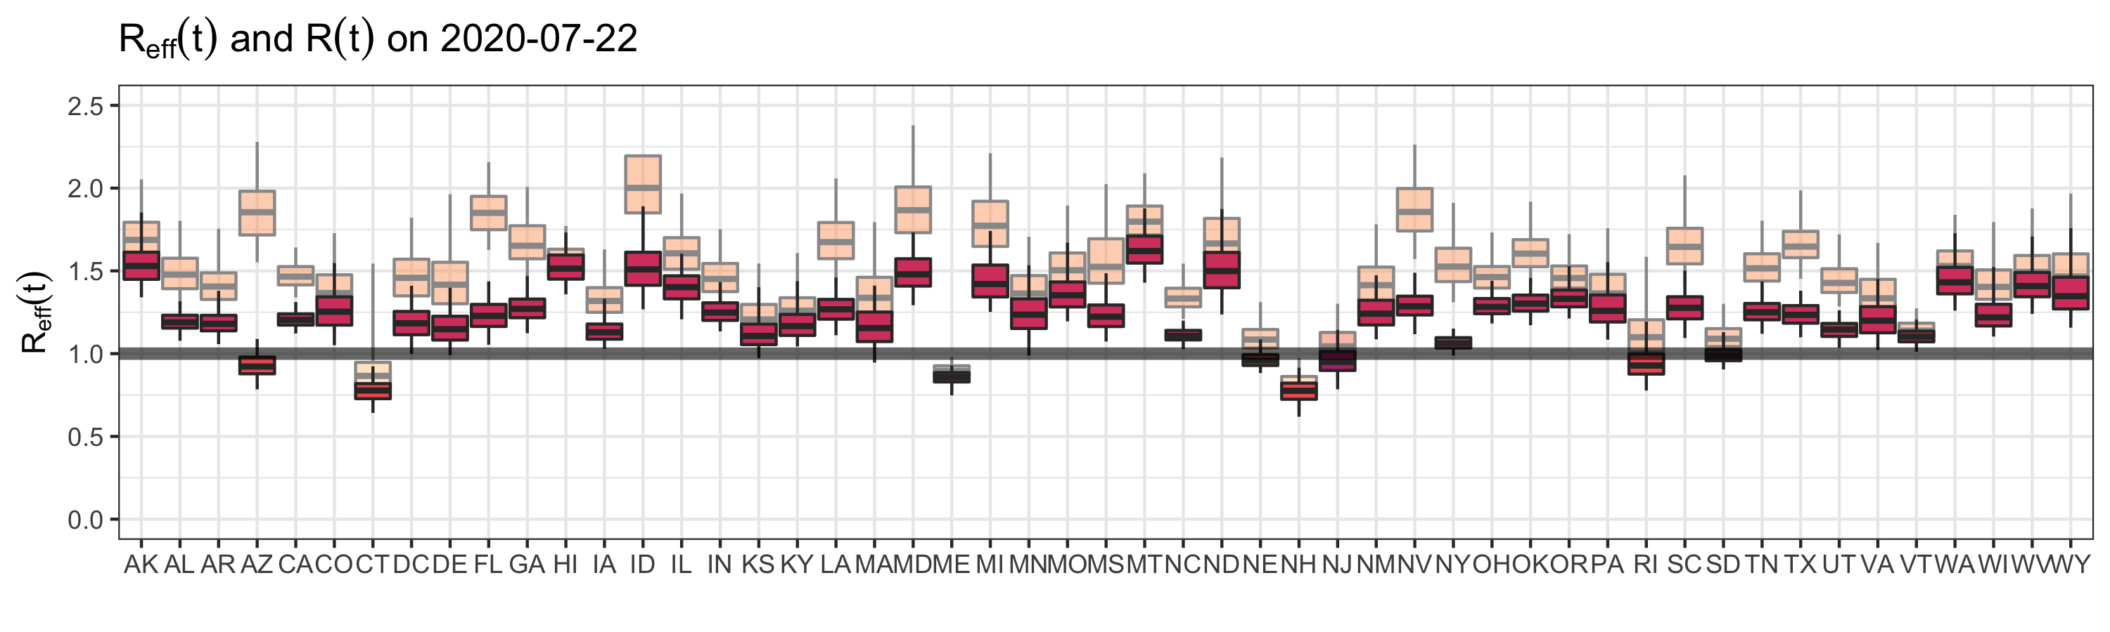

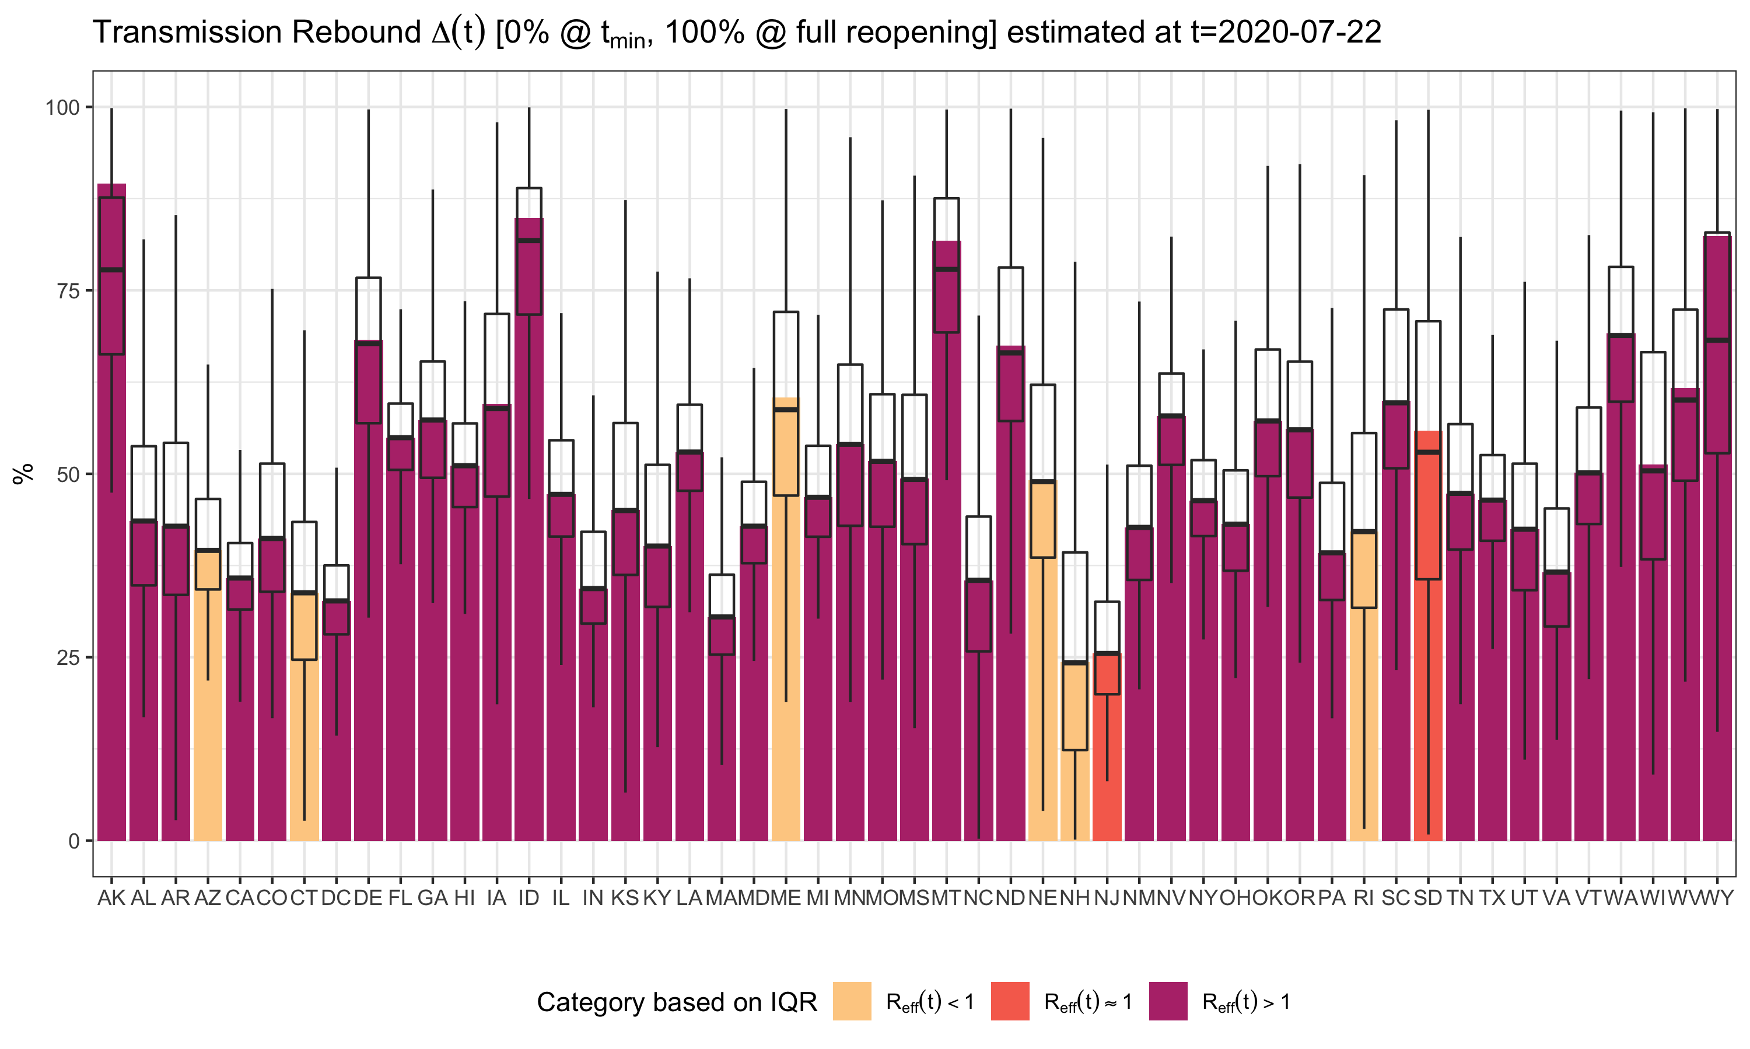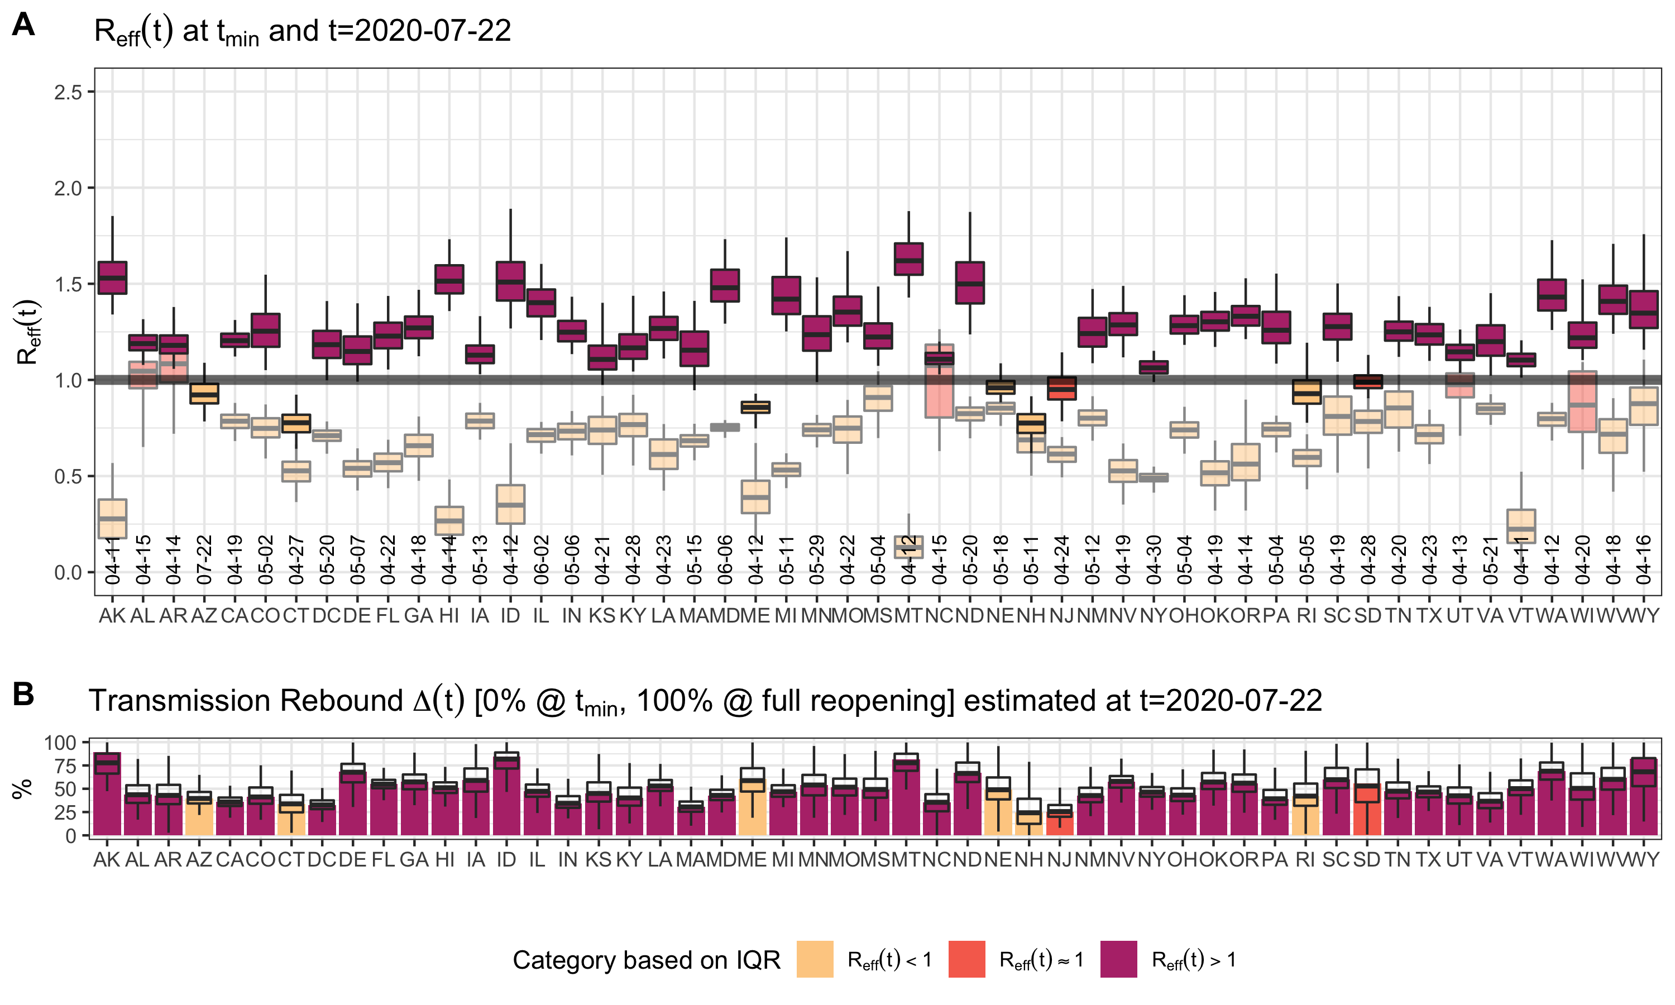

folder <- "../SEIR.reopen.state.2020.07.22"  
numDate <- as.numeric(as.Date("2020-07-22"))-as.numeric(as.Date(datezero))  
t <- numDate  
 scenparms <- data.frame()  
 for (statenow in statesarr) {   
 sampfile <- list.files(path=file.path(folder,statenow),  
 pattern="*OneTime.out",  
 full.names=TRUE)  
 parms <- read.delim(sampfile,as.is=TRUE,sep="\t")  
 names(parms)<-gsub("_1.1","",names(parms))  
 names(parms)<-gsub("GM_","",names(parms))  
 parms$state <- factor(statenow,levels=(sort(statesarr)))  
   
 ## Time dependent parameters, evaluated at last day  
 parms$ThetaFit <- (parms$ThetaMin -   
 (parms$ThetaMin - 1)*  
 exp(-((t-60)/parms$TauTheta)^parms$PwrTheta));  
 ## Reopening - increase contacts/day  
 parms$TimeReopen = 60+parms$TauTheta+parms$TauS;  
 parms$ReopenStart = (1 - 1/(1 + exp(4*(t - parms$TimeReopen))));  
 parms$ReopenStop = (1 - 1/(1 + exp(4*(t - (parms$TimeReopen+parms$TauR)))));  
 parms$ReopenPct = ((t - parms$TimeReopen)*(parms$rMax/parms$TauR)*(parms$ReopenStart-parms$ReopenStop)+parms$rMax*parms$ReopenStop);  
 ## Contacts/day  
 parms$c = parms$c0 * (parms$ThetaFit + (1 - parms$ThetaMin) * parms$ReopenPct);   
 ## Hygiene - reduce infection probability/infected contact  
 parms$HygieneFit <- parms$ThetaFit^parms$HygienePwr;  
 parms$beta <- parms$beta0 * parms$HygieneFit; # infection probability/infected contact  
 parms$Delta <- (parms$c*parms$beta -  
 parms$c0*parms$beta0*  
 parms$ThetaMin^(1+parms$HygienePwr))/  
 (parms$c0*parms$beta0 -  
 parms$c0*parms$beta0*  
 parms$ThetaMin^(1+parms$HygienePwr))  
 ## Time dependence of testing/contact tracting  
 parms$TestingTimeDep <- (1-1/(1+exp((t-parms$T50Testing)/parms$TauTesting)));   
 ## Contact tracing  
 parms$FTraced <- parms$FracTraced * parms$TestingTimeDep;  
 ## Testing  
 parms$lambda <- parms$TestingTimeDep * parms$lambda0;   
 parms$lambda_C <- parms$TestingTimeDep * parms$lambda0_C;   
 parms$rho_C <- parms$TestingTimeDep * parms$rho0_C;  
 parms$fracpos = parms$FTraced*parms$lambda_C/(parms$lambda_C + parms$rho_C)+(1-parms$FTraced)*parms$lambda/(parms$lambda+parms$rho); # fraction of infected that are tested and positive  
 ## Case fatality  
 parms$fracposmin <- parms$IFR / 0.9; # max 90% of cases fatal  
 parms$CFR <- ifelse(parms$fracpos > parms$fracposmin, parms$IFR/parms$fracpos, 0.9); # Adjust infected fatality to (tested) case fatality  
 parms$delta <- parms$rho * parms$CFR/(1-parms$CFR);  
 scenparms <- rbind(scenparms,parms)  
}  
scenparms<-scenparms[,!duplicated(names(scenparms))]  
scenparms.med<-aggregate(.~state,data=scenparms,median)

##   
## Call:  
## lm(formula = Refft ~ ., data = scenparms[, c("ThetaMin", "Refft")])  
##   
## Residuals:  
## Min 1Q Median 3Q Max   
## -0.75001 -0.10825 0.00477 0.12093 0.99441   
##   
## Coefficients:  
## Estimate Std. Error t value Pr(>|t|)   
## (Intercept) 1.448853 0.003093 468.38 <2e-16 ***  
## ThetaMin -0.544489 0.006968 -78.14 <2e-16 ***  
## ---  
## Signif. codes: 0 '***' 0.001 '**' 0.01 '*' 0.05 '.' 0.1 ' ' 1  
##   
## Residual standard error: 0.1911 on 25498 degrees of freedom  
## Multiple R-squared: 0.1932, Adjusted R-squared: 0.1932   
## F-statistic: 6106 on 1 and 25498 DF, p-value: < 2.2e-16

## 2.5 % 97.5 %  
## (Intercept) 1.442790 1.454916  
## ThetaMin -0.558147 -0.530831

##   
## Call:  
## lm(formula = Refft ~ ., data = scenparms[, c("R0", "HygienePwr",   
## "ThetaMin", "rMax", "FracTraced", "FAsymp", "lambda", "rho",   
## "Refft")])  
##   
## Residuals:  
## Min 1Q Median 3Q Max   
## -0.79529 -0.08169 0.00929 0.09017 0.62280   
##   
## Coefficients:  
## Estimate Std. Error t value Pr(>|t|)   
## (Intercept) 0.620840 0.010708 57.977 < 2e-16 ***  
## R0 0.147459 0.001931 76.383 < 2e-16 ***  
## HygienePwr -0.388909 0.006514 -59.700 < 2e-16 ***  
## ThetaMin 0.110864 0.008121 13.651 < 2e-16 ***  
## rMax 0.440123 0.003699 118.978 < 2e-16 ***  
## FracTraced -0.902707 0.007874 -114.649 < 2e-16 ***  
## FAsymp -0.017208 0.005912 -2.911 0.00361 **   
## lambda -0.125860 0.028262 -4.453 8.49e-06 ***  
## rho 0.362210 0.025216 14.364 < 2e-16 ***  
## ---  
## Signif. codes: 0 '***' 0.001 '**' 0.01 '*' 0.05 '.' 0.1 ' ' 1  
##   
## Residual standard error: 0.1392 on 25491 degrees of freedom  
## Multiple R-squared: 0.572, Adjusted R-squared: 0.5718   
## F-statistic: 4258 on 8 and 25491 DF, p-value: < 2.2e-16

## 2.5 % 97.5 %  
## (Intercept) 0.59985125 0.641829101  
## R0 0.14367483 0.151242662  
## HygienePwr -0.40167757 -0.376140471  
## ThetaMin 0.09494625 0.126781918  
## rMax 0.43287227 0.447373558  
## FracTraced -0.91813939 -0.887273789  
## FAsymp -0.02879583 -0.005620261  
## lambda -0.18125494 -0.070465382  
## rho 0.31278470 0.411634993

## Analysis of Variance Table  
##   
## Response: Refft  
## Df Sum Sq Mean Sq F value Pr(>F)   
## R0 1 72.40 72.404 3737.133 < 2.2e-16 ***  
## HygienePwr 1 57.91 57.913 2989.166 < 2.2e-16 ***  
## ThetaMin 1 100.31 100.308 5177.354 < 2.2e-16 ***  
## rMax 1 155.99 155.995 8051.610 < 2.2e-16 ***  
## FracTraced 1 268.03 268.026 13834.053 < 2.2e-16 ***  
## FAsymp 1 0.41 0.414 21.344 3.857e-06 ***  
## lambda 1 0.91 0.907 46.813 7.987e-12 ***  
## rho 1 4.00 3.998 206.330 < 2.2e-16 ***  
## Residuals 25491 493.87 0.019   
## ---  
## Signif. codes: 0 '***' 0.001 '**' 0.01 '*' 0.05 '.' 0.1 ' ' 1

## Parameter Eta_Sq CI CI_low CI_high  
## 1: R0 0.0627511625 0.95 5.718131e-02 0.0685234141  
## 2: HygienePwr 0.0501918619 0.95 4.514611e-02 0.0554587643  
## 3: ThetaMin 0.0869342783 0.95 8.055662e-02 0.0934806045  
## 4: rMax 0.1351966468 0.95 1.277144e-01 0.1427862175  
## 5: FracTraced 0.2322911401 0.95 2.237571e-01 0.2686264561  
## 6: FAsymp 0.0003583943 0.95 4.431111e-05 0.0009731077  
## 7: lambda 0.0007860463 0.95 2.486499e-04 0.0016233800  
## 8: rho 0.0034645367 0.95 2.174011e-03 0.0050504810

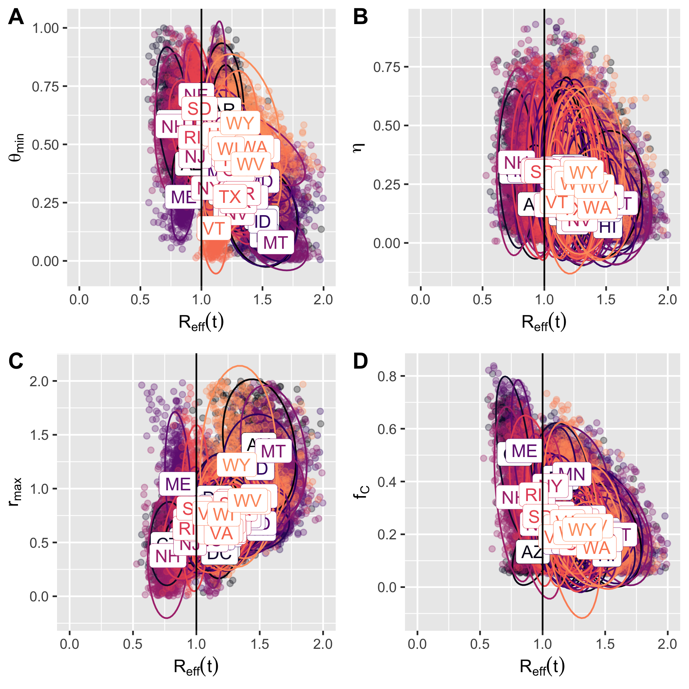

##   
## Call:  
## lm(formula = Rt ~ ., data = scenparms[, c("ThetaMin", "Rt")])  
##   
## Residuals:  
## Min 1Q Median 3Q Max   
## -1.04339 -0.14311 0.00691 0.15974 2.24945   
##   
## Coefficients:  
## Estimate Std. Error t value Pr(>|t|)   
## (Intercept) 1.801253 0.004302 418.72 <2e-16 ***  
## ThetaMin -0.818964 0.009691 -84.51 <2e-16 ***  
## ---  
## Signif. codes: 0 '***' 0.001 '**' 0.01 '*' 0.05 '.' 0.1 ' ' 1  
##   
## Residual standard error: 0.2657 on 25498 degrees of freedom  
## Multiple R-squared: 0.2188, Adjusted R-squared: 0.2188   
## F-statistic: 7142 on 1 and 25498 DF, p-value: < 2.2e-16

## 2.5 % 97.5 %  
## (Intercept) 1.7928215 1.8096850  
## ThetaMin -0.8379581 -0.7999701

##   
## Call:  
## lm(formula = Rt ~ ., data = allparms[, c("R0", "HygienePwr",   
## "ThetaMin", "rMax", "FracTraced", "FAsymp", "lambda", "rho",   
## "Rt")])  
##   
## Residuals:  
## Min 1Q Median 3Q Max   
## -0.94355 -0.07643 0.00075 0.07636 1.13525   
##   
## Coefficients:  
## Estimate Std. Error t value Pr(>|t|)   
## (Intercept) 0.122083 0.011108 10.99 <2e-16 ***  
## R0 0.314068 0.002002 156.84 <2e-16 ***  
## HygienePwr -0.840976 0.006757 -124.46 <2e-16 ***  
## ThetaMin 0.621163 0.008424 73.74 <2e-16 ***  
## rMax 0.693221 0.003837 180.66 <2e-16 ***  
## FracTraced -1.621546 0.008167 -198.54 <2e-16 ***  
## FAsymp 0.369897 0.006132 60.32 <2e-16 ***  
## lambda -3.248934 0.029315 -110.83 <2e-16 ***  
## rho 0.844522 0.026156 32.29 <2e-16 ***  
## ---  
## Signif. codes: 0 '***' 0.001 '**' 0.01 '*' 0.05 '.' 0.1 ' ' 1  
##   
## Residual standard error: 0.1444 on 25491 degrees of freedom  
## Multiple R-squared: 0.7736, Adjusted R-squared: 0.7735   
## F-statistic: 1.089e+04 on 8 and 25491 DF, p-value: < 2.2e-16

## 2.5 % 97.5 %  
## (Intercept) 0.1003114 0.1438541  
## R0 0.3101431 0.3179931  
## HygienePwr -0.8542204 -0.8277313  
## ThetaMin 0.6046514 0.6376738  
## rMax 0.6856999 0.7007417  
## FracTraced -1.6375537 -1.6055375  
## FAsymp 0.3578770 0.3819165  
## lambda -3.3063937 -3.1914742  
## rho 0.7932544 0.8957896

## Analysis of Variance Table  
##   
## Response: Rt  
## Df Sum Sq Mean Sq F value Pr(>F)   
## R0 1 313.19 313.19 15024.0 < 2.2e-16 ***  
## HygienePwr 1 183.42 183.42 8799.0 < 2.2e-16 ***  
## ThetaMin 1 137.06 137.06 6574.8 < 2.2e-16 ***  
## rMax 1 247.37 247.37 11866.6 < 2.2e-16 ***  
## FracTraced 1 590.89 590.89 28345.8 < 2.2e-16 ***  
## FAsymp 1 34.34 34.34 1647.3 < 2.2e-16 ***  
## lambda 1 287.87 287.87 13809.6 < 2.2e-16 ***  
## rho 1 21.73 21.73 1042.5 < 2.2e-16 ***  
## Residuals 25491 531.38 0.02   
## ---  
## Signif. codes: 0 '***' 0.001 '**' 0.01 '*' 0.05 '.' 0.1 ' ' 1

## Parameter Eta_Sq CI CI_low CI_high  
## 1: R0 0.133427353 0.95 0.125976760 0.14098737  
## 2: HygienePwr 0.078143195 0.95 0.072033879 0.08443328  
## 3: ThetaMin 0.058390278 0.95 0.052992825 0.06399673  
## 4: rMax 0.105386882 0.95 0.098521560 0.11239642  
## 5: FracTraced 0.251737301 0.95 0.191742209 0.26034901  
## 6: FAsymp 0.014629805 0.95 0.011854049 0.01768245  
## 7: lambda 0.122642519 0.95 0.115397651 0.13000985  
## 8: rho 0.009258333 0.95 0.007069148 0.01173527

